City University

Project Name: Online shopping

Course Name: System analysis & Design.

Course Code: CSE 325

Submitted by:

Name: Shamim Ahammed

ID: 171442617

Program: CSE(Eve)

City University

Submitted by:

Name: Sharmim

ID: 171442621

Program: CSE(Eve)

City University

Submitted by:

Name: Jiniaur Baby

ID: 171442633

Program: CSE(Eve)

City University

Submitted To:

Supta Rechard Philip

Sr.Lecturer, Department of CSE

City University

Submitted Date: 05-July-2019

Contents

Table of Contents

Chapter-1 Introduction to online shopping.

1.1 Problem Statement 3

1.2 Proposed Solution 3

1.3 Project Structure 4

Chapter-2 Related project. 5

2.1 Project-1: 5

2.2 Project-2: 6

Chapter-3 Analysis 7

3.1 Feasibility Study 7

3.1.1Technical Feasibility 7

3.1.2 Behavioral Feasibility 7

3.1.3Economical Feasibility 7

3.2 Requirement gathering 7

3.3 Document Reading. 8

3.4 Questioner 8

3.5 Observation 8

3.6 Interview. 8

Chapter-4 Function & Non-Function 9

4.1 Functionality: 9

4.2 Non-Functionality: 9

Administrator: 9

User: 9

Chapter-5 Design 10

5.1 Use case Diagram Description. 10

5.2 Use case Diagram Figure. 10

5.3 Activity diagram description: 11

5.4 Activity diagram figure: 11

5.5 Sequence Diagram Description 12

5.6 Sequence Diagram Figure 12

5.7 Class Diagram Description 13

5.8 Class Diagram Figure 13

## 1.1 Problem Statement

A problem is well defined very rarely. So, the first task is to get more crucial information by interviewing and meeting concerned people. It clarifies how the problem is felt, how often it occurs, how it affects the business and which departments are suffering with this. This phase consists of the following tasks. This was a preliminary investigation done with a view to have a “feel” of the workings of the proposed system. This phase has been identified the end-user directly involved in the system who were the managers, assistant officer and database administrator, and the development department. By understanding the working of database, its flow and also after conducting meetings and interviews with the concerned persons of the department, a clear idea about the working was obtained. A flexible approach is adapted towards people who are interviewed. Short hand written notes are prepared based on the response of the employees. Detailed investigation is done in order to define the scope of the problem. The interview is concluded with a quick resume of the ground covered during the interview. The Questionnaire technique is combined with interviews to get the best result. Proper care has been taken in the design of such questionnaires so that the persons answering these questions do not feel hesitant. An explanatory note that serves to gain cooperation and avoid misunderstanding by setting out the purpose of the exercise clearly accomplishes each questionnaire. Observation technique is also used for fact finding. The work described at the time of interview is observed personally ads it reduces the chances of misunderstanding and omissions. Some important things observed are like the flow of information through the system and important data transactions, the data being maintained and the frequency of their updating. By the end of this phase, idea as to how the information enters the system, how it is stored, how it is processed, how information changes affect the workings of the system and finally the output format required by the end-user was collected. All the information generated from this phase acted as an input to the next phase.

## 1.2 Proposed Solution

The development of this application contains the following activities

• Profile management facility for customers in a secure manner

• All the products are accessed through email like kitchen accessories, Food items.

• Shopping cart is also created for customers for total amount checking

• Recent offers updates to customers via mail

• About most of them purchased are shown.

## 1.3 Project Structure

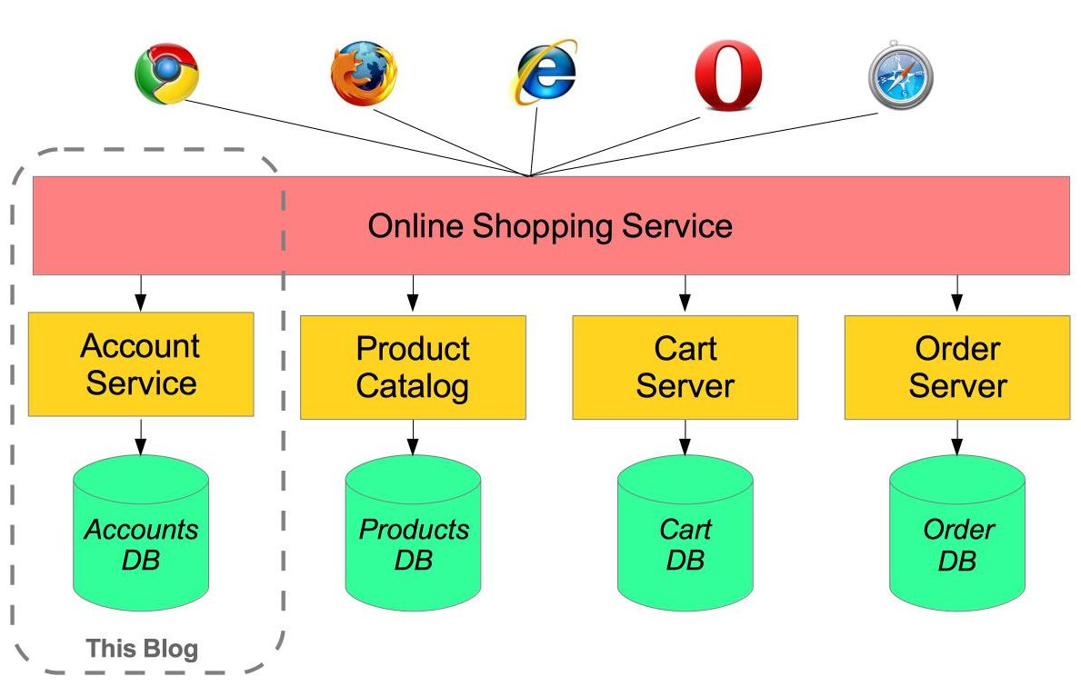

# Chapter-2 Related project.

## 2.1 Project-1:

Chal Dal.Com: Chal Dal is a most popular online shopping site in Bangladesh. Their all activity‘s understanding & clear concept in given bellow link.

<https://chaldal.com/?gclid=EAIaIQobChMIlrnu19Sc4wIVizgrCh2kfg1hEAAYASAAEgKiXvD_BwE>

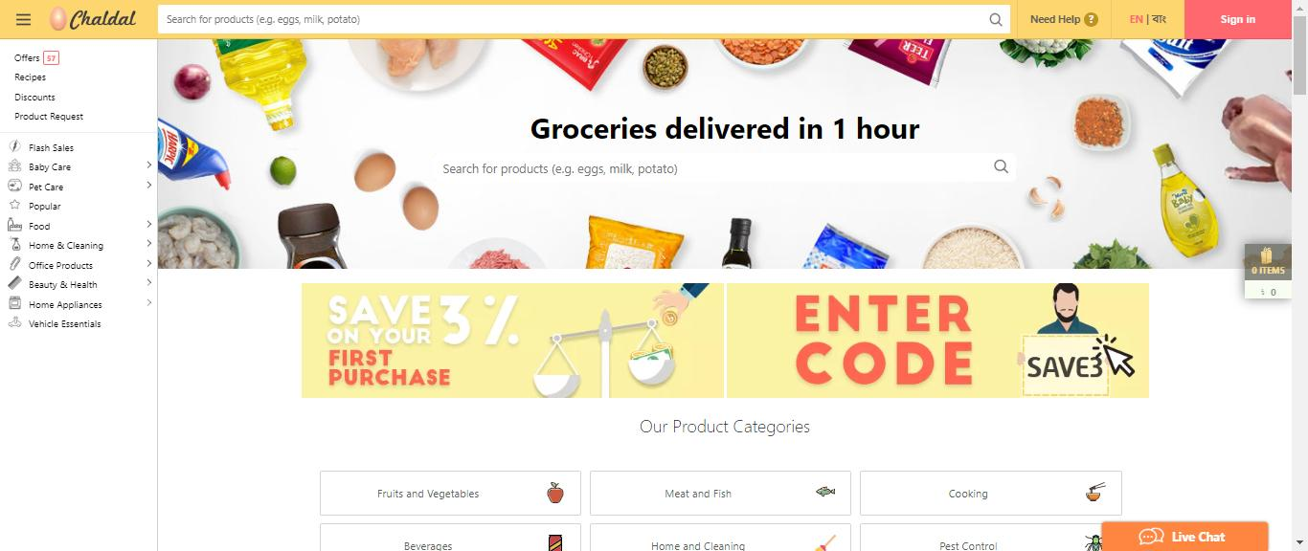

## 

## 2.2 Project-2:

Daraz Bd.Com

Chal Dal.Com: Daraz Dal is also most popular online shopping site in Bangladesh. Their all activity‘s understanding & clear concept in given bellow link.

[https://www.daraz.com.bd/?gclid=EAIaIQobChMIjKGlq9ac4wIVkBSPCh2KyQqlEAAYASAAEgIhDvD_BwE#](https://www.daraz.com.bd/?gclid=EAIaIQobChMIjKGlq9ac4wIVkBSPCh2KyQqlEAAYASAAEgIhDvD_BwE)

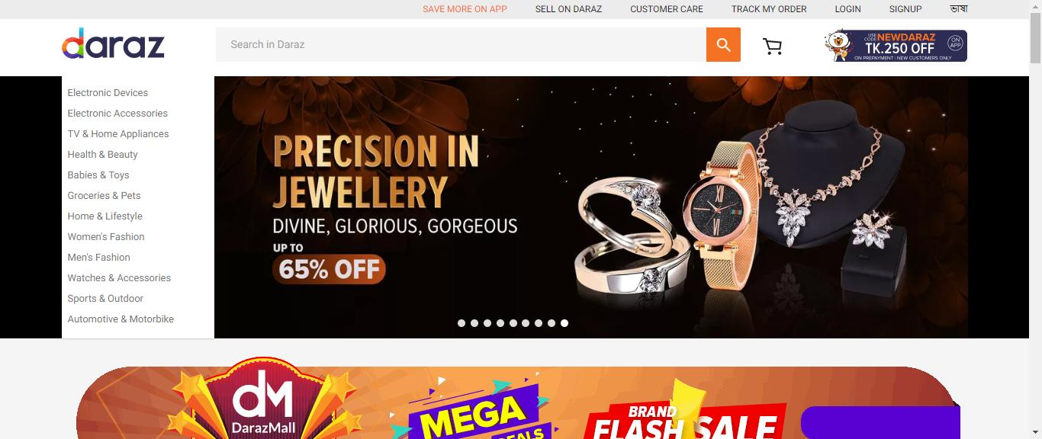

# Chapter-3 Analysis

## 3.1 Feasibility Study

In preliminary investigation feasibility study has three aspects.

## 3.1.1Technical Feasibility

To deploy the application, the only technical aspects needed are mentioned below:Operating Environment Win 2000/XPPlatform .Net Framework & IISDatabase SQL Server 2005

For Users:

Internet BrowserInternet Connection

## 3.1.2 Behavioral Feasibility

The application requires no special technical guidance and all the views available in the application are self explanatory. The users are well guided with warning and failure messages for all the actions taken.

## 3.1.3Economical Feasibility

The project is economically feasible as the only cost involved is having a computer with the minimum requirements mentioned earlier. For the users to access the application, the only cost involved will be in getting access to the Internet.

## 3.2 Requirement gathering

Create and maintain account evident

View shopping history Hidden

Add a product by merchant Evident

Delete a product by merchant Evident

Update a product by merchant Evident

Add a product in the cart by customer

EvidentIf there time password wrong then stop asking password Frill

Search the required item Hidden

Store the product in the category Hidden

GUI should be same in different browsers Evident

System should validate credit card information Evident

Give information about latest products Evident

Compare the prices of different brands Fril

## 3.3 Document Reading.

To follow this particular method of fact-finding, Analysthas to study well existing documentation, forms, and files of existing system. A good analyst gets fact first from existing documentation rather than from people.

## 3.4 Questioner

This is a special purpose document that allows the analyst to collect information and opinions from respondents. Questionnaires become useful when a little information is required from a number of people.

## 3.5 Observation

Observation could be Formal or Informal. This is most effective when an analyst wants to obtain an understanding of a system. This technique used when analyst wants either participates in or watches a person perform activities to learn about the system.

## 3.6 Interview.

This technique of fact-finding is most popular, productive for good analysts and most probably widely used. Interviews are a fact-finding technique where by the systems analysts collects information from individual fact to face.Interviewing can be used to find-facts; verify facts; clarify facts; general enthusiasm etc.

# Chapter-4 Function & Non-Function

## 4.1 Functionality:

1.Enable customers buy online.

2. Enable customers to easily browse through the products.

3. Enable customers to search products.

4. allowing customers to posterior sand discuss products and sell through us.

5. allow the businessman to manage the shop inventory.

6. allow the businessman to view graphs depicting previous sales etc.

7. allow the businessman to change the look and feel of the site with ease.

8. allow the shopkeeper to view different configuration options and update them.

## 4.2 Non-Functionality:

Functional requirements describe the interaction between the system and its environment independent of its implementation.

## Administrator:

He is provided with the information of users and products and he can update the system software to meet the requirements.

## User:

The user can view the details of products by entering the URL of the website.

He should be able to search for a particular product.

He can just view the details but cannot manipulate them.

# 

# Chapter-5 Design

## 5.1 Use case Diagram Description.

Web Customer [actor](https://www.uml-diagrams.org/use-case-actor.html) uses some website to make purchases online. Top level [use cases](https://www.uml-diagrams.org/use-case.html) are View Items, Make Purchase and Client Register. View Items use case could be used by customer as top-level use case if customer only wants to find and see some products. This use case could also be used as a part of Make Purchase use case. Client Register use case allows customers to register on the web site, for example to get some coupons or be invited to private sales. Note, that Checkout use case is [included use case](https://www.uml-diagrams.org/use-case-include.html) not available by itself - checkout is part of making purchase.

## 5.2 Use case Diagram Figure.

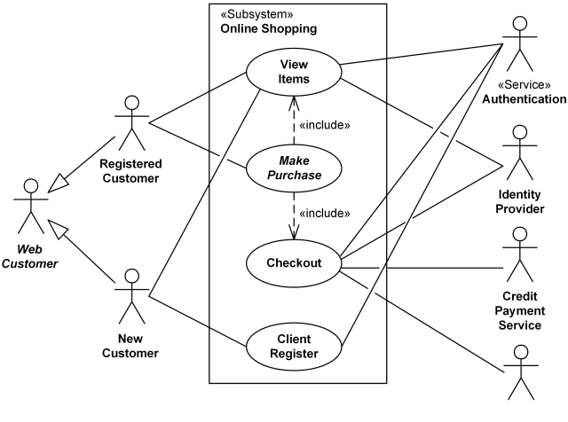

## 5.3 Activity diagram description:

Activity diagram is another important diagram in UML to describe the dynamic aspects of the system. Activity diagram is basically a flowchart to represent the flow from one activity to another activity. The activity can be described as an operation of the system. The control flow is drawn from one operation to another

## 5.4 Activity diagram figure:

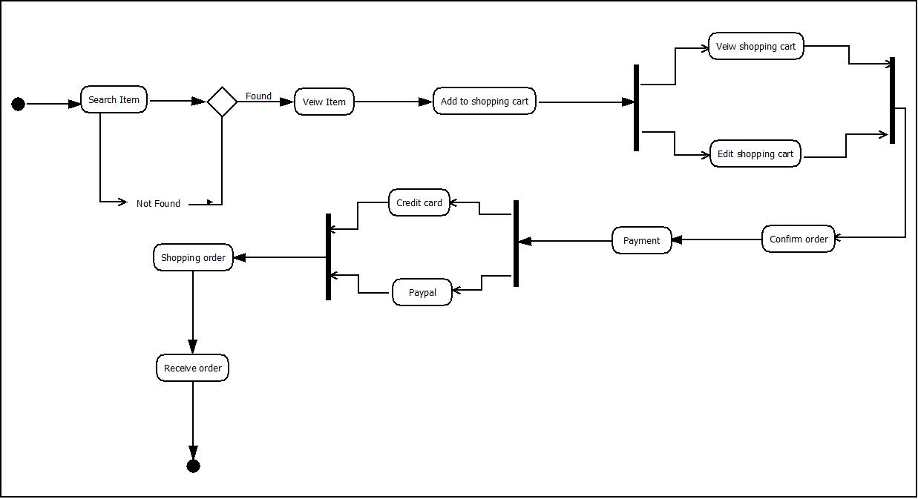

## 5.5 Sequence Diagram Description

Many project managers and engineers use sequence diagrams in UML to get a better idea of how tasks within a project will function, overlap, and move between objects or components. Create sequence diagrams to display interactions between objects and the order in which those interactions occur.

## 5.6 Sequence Diagram Figure

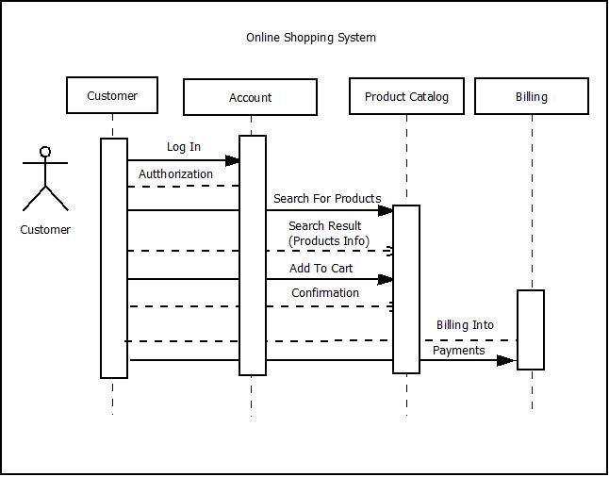

## 5.7 Class Diagram Description

From all the software engineers we've talked to, we've found a common theme: no one likes to create documentation. UML diagrams can be incredibly helpful when you need to onboard employees or reference source code during implementation, but they become outdated quickly and take hours to build—unless you use a UML diagram tool like Lucidchart.

We've compiled templates for three types of structural UML diagrams—class, component, and object diagrams—and three types of behavioral UML diagrams—activity, sequence, and use case diagrams. Find a template to document your systems faster than ever.

## 5.8 Class Diagram Figure

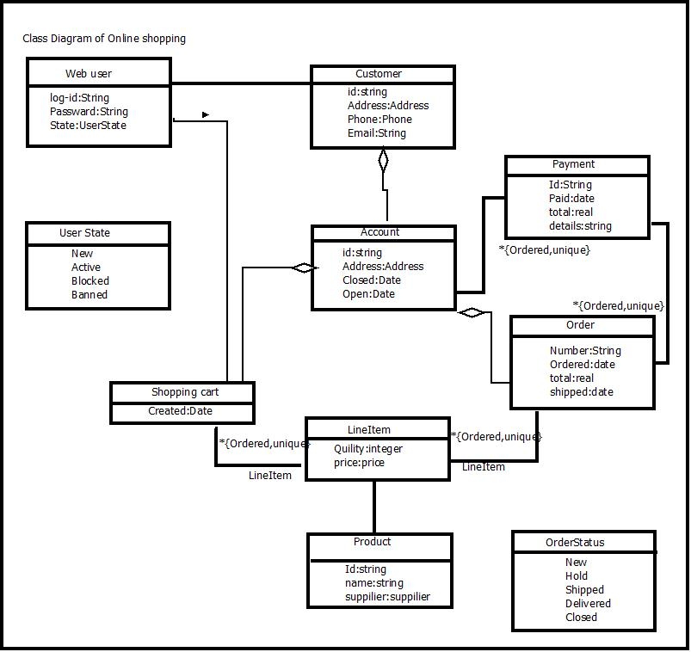

#### Chapter -6

##### Conclusion

The ‘Online Shopping’ is designed to provide a web based application that would make searching, viewing and selection of a product easier. The search engine provides an easy and convenient way to search for products where a user can Search for a product interactively and the search engine would refine the products available based on the user's input. The user can then view the complete specification of each product. They can also view the product reviews and also write their own reviews. Use of Ajax components would make the application interactive and prevents annoying post backs. Its drag and drop feature would make it easy to use